Shabbos Stories for
Parshas shemini 5781
Volume 13, Issue 32 28 Nisan/April 10, 2021
Printed L’illuy nishmas Nechama bas R’ Noach, a”h

For a free subscription, please forward your request to keren18@juno.com
Past stories can be found on the website ShabbosStories.com

The Fancy Glass of Water
Rav Yisroel Salanter, zt”l, once left his family and students to go to Paris to try to influence the assimilated Jews there to return to Torah Judaism. One day, he entered an elegant hotel to meet some wealthy Jews who frequented that hotel. He sat down in the lobby and ordered a glass of water.
When the waiter brought him the bill, it was for an exceedingly high amount of money, and he asked the waiter why the bill was so high, simply for a cup of water.
The waiter responded that Rav Yisroel was not paying merely for a glass of water. The charge included the surroundings and ambience in which he drank the water. He was paying for the exquisite furniture, lighting, carpeting, and stunning surrounding view, as well as the water.
Later, Rav Yisroel wrote the following letter to his students: “For a long time I have been puzzled by the fact that we recite a very lofty and all-inclusive Brachah for a plain glass of water. We say, ‘Shehakol Nihiyeh Bidvaro’, which means that through Hashem’s word, everything came to be.
“But from the words of a gentile waiter in Paris, I learned that we are not merely thanking Hashem for the glass of water, we are expressing our appreciation for the magnificent surroundings in which Hashem serves the water to us. We are thanking Hashem for the fresh air we breathe as we drink that water, and for the sun that gives us light, and for the tree that shades us. In short, whenever we thank Hashem for one thing, we should use it as an opportunity to thank Hashem for everything!”

Reprinted from the Parsha Mikeitz 5781 email of Torah U’Tefilah as compiled by Rabbi Yehuda Winzelberg.

Two Chassidic Stories

There is a famous story in Chassidic lore. Two holy brothers, Rav Zusha and Rebbe Elimelech, were once thrown into jail on trumped up charges. One morning, Rabbi Zusha noticed his brother weeping silently.
"Why do you cry?" asked Rabbi Zusha. R’Elimelech pointed to the pail situated in the corner of the room which the inmates used for a toilet.
"Halacha forbids one to pray in a room inundated with such a repulsive odor," he told his brother. "Today, for the first time in my life I will not be able pray and do what Hashem wants."
"You are doing the Will of Hashem," insisted Rav Zusha. "The same Hashem who commanded you to pray each morning, also commanded you to abstain from prayer under such circumstances. In a location such as this, you do the Will and connect to Hashem by the absence of prayer."

Changes in Plans are Unavoidable
In life, changes in plans are an unavoidable part of the nature of world events, and sometimes we can get frustrated and disappointed since we have invested so much in hopes of a certain outcome. However, we must realize that it’s not about us and what we want, but rather about what Hashem wants.
Then, it doesn’t matter what happens since whatever does happen is the Ratzon (Will of) Hashem. This realization is something that will help us keep going and avoid getting into negative moods and outlooks.

Reb Baruch of Mezibuzh, O”BM, was raised in the home of the saintly Reb Pinchas of Koritz. Even after Reb Baruch married and established a home of his own, he’d often visit Reb Pinchas. On one such visit, Reb Baruch lay asleep in Reb Pinchas’ home.
“Gather around Reb Baruch’s bed,” Reb Pinchas told the members of his household, “and I will show you something you’ve never seen before.”
The family stood near Reb Baruch’s bed and watched as Reb Pinchas approached the mezuzah on the doorpost and covered it with his hand. Reb Baruch immediately began to stir. Reb Pinchas then removed his hand from the mezuzah, and immediately Reb Baruch resumed sleeping peacefully.
Reb Pinchas repeated this “experiment” a few of times with the same results. “See how great is Reb Baruch’s holiness,” Reb Pinchas said. “Even in his sleep he is not distracted for a moment from his strong attachment to Hashem!”

Reprinted from the Parshas Mikeitz 5781 email of Torah Sweets Weekly.

Rav Levi Yitzchok and
The Large Feather Pillow

There is a story that is attributed to Rav Levi Yitzchok of Berdichev, zt”l. A man who spread many malicious stories about others and gossiped incessantly, wished to correct his bad ways and do Teshuvah for his Lashon Hara.
He approached Rav Levi Yitzchok and asked him what he could do about this, and Rav Levi Yitzchok told him to bring him a large feather pillow. When he returned, Rav Levi Yitzchok instructed him to cut open the pillow, and scatter the feathers in the wind. The man did as he was told, and when he returned to tell Rav Levi Yitzchok that he had followed the instructions, he was informed of the second step.
Rav Levi Yitzchok said to him, “Now go and gather all the feathers.”
The man was incredulous and said, “That is impossible! The wind blew the feathers in all directions. I can’t possibly collect them!”
Rav Levi Yitzchok responded to him, “That is exactly right. You cannot collect all the feathers. Lashon Hara is the same way. Just as you cannot collect the feathers, you cannot take back all the bad words you have spoken either, as they also spread and fly in the wind.”
The man was heartbroken at what the Rebbe had told him. Rav Levi Yitzchok said, “Now you understand. When we speak badly about another person, the effect is far and wide, and it is damage that can never be fully undone.”
Rav Levi Yitzchok gave him instructions on how to correct his Aveiros, and the man worked on correcting this bad trait!

Reprinted from the Parshas Mikeitz 5781 email of Torah Sweets Weekly.

Shira’s Unexpected Miracle

Shira was 18 years old when she started searching for the meaning of life. She read a lot and was always trying to find her way, when she finally came to Judaism. After a long period of personal empowerment, she decided to become Frum.
At first, she did everything quietly, and this did not bother her parents. They thought that there was nothing wrong with a little tradition. But then, later, when the family began to realize that Shira was serious about her religious observance, they began making things extremely difficult for her. This was a great challenge for Shira that she tried very hard to overcome.

The Mysterious Unplugging of the Shabbos Hot Plate
For example, the hot plate that she prepared for Shabbos was mysteriously unplugged, and she was forced to eat cold food throughout the entire Shabbos. But she remained determined, and decided not to give up. Shira sometimes would have tears in her eyes because of the difficulties she had to go through, but she kept strengthening herself by reminding herself that she used to be like the rest of her family too, and she hoped in her heart that one day, they too would see the light and truth.
At a certain point she starting hoping for the day in which she could leave her current home, and build a home of her own with her husband, in which they would observe Torah and do Mitzvos with joy. As soon as she felt ready and started dating, an additional difficulty began to develop.

Father Became Enraged Over Shira’s
Plan to Marry a Boy Who Learned Torah
Shira’s father, who knew that his daughter wanted to marry a boy who learned Torah, became enraged with what she was looking for, and told her that a boy like that will never step foot into his house, no matter what! One day, Shira’s father made a call to his wife, but by mistake, he dialed the wrong number. Without realizing his error that he called the wrong person, he automatically began speaking to the woman who answered in Bucharian, the native language spoken at Shira’s house, and the lady on the other end of the line, surprisingly, responded to him in the same language!
The father quickly apologized, and a split second before the conversation ended, the father asked the woman out of curiosity what her last name was, as Bucharians all seem to know each other. From that point, they started conversing, and somehow, the conversation lead to the father telling the woman that he was having a very difficult time with his daughter, who had become religious.
To his amazement, the woman began telling him that she too had a son who was driving her crazy with his religious observance, and how he studied in Yeshivah all day!

An Astonishing Phone Call
Shortly after this conversation, to Shira’s astonishment, she received a phone call from her father, who informed her, without much information, that she would be having a date on the following day with this boy. Shira, who expected to encounter someone who met her father’s expectations, was shocked to see a Yeshivah boy arrive for the date, just like she had wanted all along!
After several dates, the couple announced their engagement! As it turned out, for the first time in his life, a real Yeshivah boy stepped foot in her father’s house, dressed in a black suit, a white shirt, and a hat. At the moment that happened, countless memories crossed Shira’s mind of the times her father warned her not to ever bring home a Yeshivah boy. And in truth, she never did. It was her father who had brought him home! Today, they are happily married for many years, and live in Israel happily raising their family!

Reprinted from the Parshas Mikeitz 5781 email of Torah Sweets Weekly.
Shabbat is Sacred

Years ago, two brothers from the community owned a jewelry store in Williamsburg. Erev Shabbat, the alarm company called one of the brothers to notify him that his safe was triggering the alarm, because it was left open.
The brothers contemplated asking for a heter—allowance in order to get a car to Williamsburg to check on the safe, but they were uncomfortable with the idea of desecrating Shabbat, no matter what the issue. They decided to ignore the alarm company’s warning.

Every Hour They Got a Call from the Alarm Company
All through Shabbat, the men tried to enjoy like it was any other, but every hour, the alarm company called their houses and left messages saying that the safe was open. They had emunah that everything would be okay, and they took their time and waited until a few hours after Shabbat was over to go check on the safe.
When they got there, they saw the store had been robbed. Jewelry cases were broken, glass was everywhere. One of the brothers went to the safe and prayed that nothing was taken from it. The items in the displays were just the tip of the iceberg to what was inside the store’s safe. Baruch Hashem, the safe was locked, and everything inside was intact. The police were at the store, and they asked the owners why it took so long for them to arrive, as the robbery had been the night before. The brothers explained it was the Sabbath, and they couldn’t come in order to keep the day sacred.

The Amazed Police Officer
The police officer was amazed. “Come with me,” he said to them. He led the men upstairs, where he directed them to a hole in the floor, with some protruding wires, abandoned guns. and a perfect view of the safe.
“You see,” said the officer, “These men that came were professionals. They played with the wires to trigger the alarm. Once the owners showed up, they would open the safe to check on its contents, and the burglars would shoot them and clear it out. They triggered your alarm every hour to get you here, and you didn’t come. If not for your Sabbath, you would’ve lost your money, and your lives.”

Reprinted from the Parshat Beshalach 5781 email of Jack E. Rahmey as based on the Torah teachings of Rabbi Amram Sananes.

The Widow and
The Baal Shem Tov

There is a known story: A widow came to the Baal Shem Tov's beis hamidrash one motzei shabbos, while the Baal Shem Tov and his students were still davenning maariv. She waited until the minyan concluded davening (praying) and then cried to the Baal Shem Tov, that she is a widow who has no money, and now she needs a large sum of money for her daughters’ wedding.
The Baal Shem Tov instructed his students to put their hands in the pocket and to give her all the money they have. The students immediately obeyed and to everyone's amazement it added up exactly to the amount she desperately needed.
When the Alter Rebbe repeated this story, he asked his students to explain, what was the amazing point in this story?
One student replied that they found money which obviously was not in their pockets a few moments earlier. Another student said that they found collectively the exact amount she mentioned, not a ruble more or less.

The Alter Rebbe said, obviously those are nice points, but compared to other miracles of the Baal Shem Tov, they are not outstanding points, that you would call miraculous.
The miracle is that the students knew that their pockets were empty; after all it was just Shabbos. Yet they believed the Baal Shem Tov and put their hands in their pockets knowing that they will find some money.

Reprinted from the November 26, 2020 email of Rabbi Sholom DovBer Avtzon’s Weekly Story. Rabbi Avtzon is a veteran mechaneh and the author of numerous books on the Rebbeim and their chassidim. He can be reached at avtzonbooks@gmail.com

The Crying Woman and
The Jerusalem Tzadik

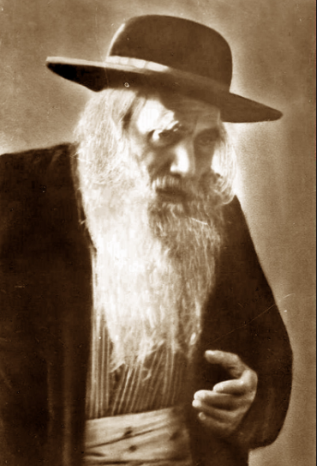

During the early 1900’s Rabbi Yosef Chaim Sonnenfeld (1848-1932) served as Chief Rabbi of Jerusalem. He lived in the Old City but would travel anywhere to perform a berit milah. One day, Reb Yosef Chaim was asked to perform a berit milah on an infant whose parents lived in one of the poverty-stricken areas of the city.
On the designated day, he made his way to the neighborhood of the young couple. He knew there would be very few people at the milah, for the family had no money to tender a festive meal afterwards.
As Reb Yosef Chaim entered the courtyard of the apartment complex, he heard a baby cry. The sound was coming from the building where the milah was to be. He followed the voice and knocked on the door.
A young woman answered the door. “Mazal tov,” said Reb Yosef Chaim. “I am here to do the berit milah for your son.”
“Oy, Rebbi,” sighed the woman. “I only wish you were in the right house!”
Seeing the great Rabbi unexpectedly, the woman started crying. “Rebbi, I have been married so many years and my husband and I have no children. Please bless me.” Then she added, “The child is next door; it’s my neighbor who had the baby.”
She turned away, wiping her tears in embarrassment for her brazenness in asking the great sadik for a berachah. She was ashamed that she had broken down and revealed her plight.
Reb Yosef Chaim felt terrible that he had been the cause of the woman’s anguish. By walking into the wrong apartment he had inadvertently brought forth her sad situation.
Reb Yosef Chaim said softly and compassionately, “I give you a berachah that I should come back to your home next year and it won’t be a mistake. It will be for a simchah.”
A year later the woman had a little boy, and Reb Yosef Chaim was called to perform the berit milah. It was the only child the woman ever had. (Reflections of the Maggid)

Reprinted from the Parshat Veyera 5781 email of Shabbat Shalom from Cyberspace as compiled by Rabbi David Bibi.

The Ochberg Orphans: Saving 197 Jewish Orphans
By Dr. Yvette Alt Miller

Although Peggy Gaby was orphaned at a young age, she always kept in touch with the beloved man she called father.
“It’s difficult to read the letter,” Peggy’s granddaughter, Yael Pritzker of Atlanta, recently explained to Aish.com as she slowly picked out the faded words of one of her family’s precious heirlooms, a letter her grandmother wrote to the man who saved her life.
“Dear Father Ochberg, First a little letter to let you know that we all are well. We received a letter from you. I was very happy to hear that you and your family arrived safely…”

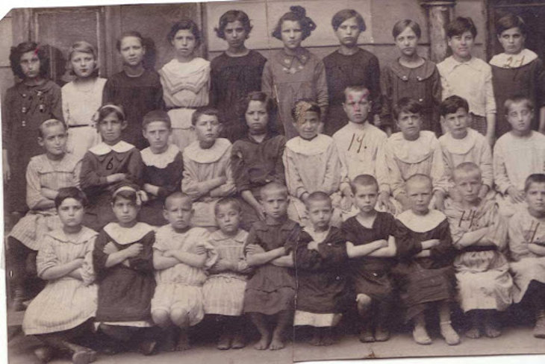

Peggy Gaby was born in Kovel, a town in Ukraine in 1910. Known as Pesha then, she only spoke Yiddish and lived in the most dire circumstances, like hundreds of thousands of Jews in Eastern Europe at the time. Her father, brother and sister had died of typhus and starvation; her mother had died from a stroke. Only Peggy and her two sisters survived. They were so poor that one of her sisters only possession was a dress made out of sack-cloth that she wore every day.
The early 1920s was a terrible time for Jewish orphans in Eastern Europe – and their numbers were staggering. It’s estimated that in 1921, over 350,000 Jewish children were orphans across the region.
Ravaged by hunger, typhus and other diseases, they were also buffeted by the brutal civil war that was raging in Russia between the Bolsheviks and the White Army. Both sides saw Jews as fair prey, and reports of vicious pogroms were heard daily, as Jews were massacred in parts of Russia, Ukraine, Belorussia, Poland, and beyond.

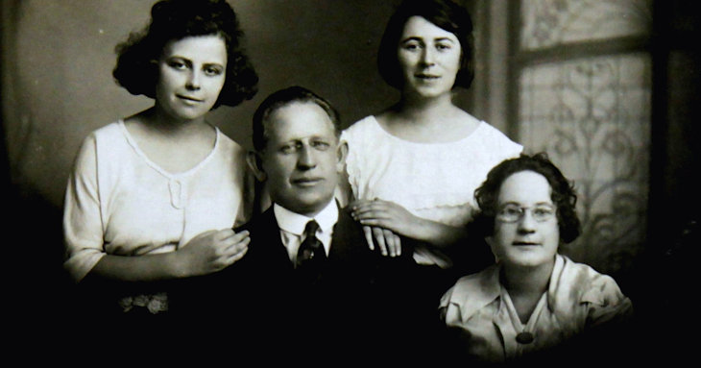Isaac Ochberg with his wife Polly and daughters Ruth (left) and Bertha (right)

Desperate Jews sent letters to Jewish communities abroad, pleading for aid. One of these letters reached the Jewish community in Cape Town in South Africa, where it galvanized the community. Many South African Jews at the time were themselves immigrants from Eastern Europe. They knew firsthand the intense Jew-hatred of the places they’d left and they feared for their co-religionists left behind, particularly defenseless Jewish orphans.
One of the Cape Town Jews who debated the desperate plight of Russian Jews was Isaac Ochberg. Born in Ukraine, he’d moved to South Africa in 1894 at the age of fifteen. By 1920, he was a successful businessman and he wanted to help. Instead of merely pledging funds or declaring his concern, Ochberg decided to take concrete action.
Instead of delegating responsibility to others, he started making plans to travel to Eastern Europe himself and see what he could do to help rescue Jewish orphans. Other South African Jews pledged funds to help him make his life-saving trip.
Before setting sail, Ochberg arranged a meeting with South Africa’s Prime Minister, Jan Smuts, to ask for permission to bring Jewish orphans back to South Africa. Mr. Smuts’ answer was disappointing: he’d allow no more than 200 Jewish orphans into the country. Moreover, these orphans had to be under sixteen years old, have no living parents, and not be missing any limbs. Ochberg agreed, though in time he’d break all three of those rules.
In 1920, Ochberg set off to Eastern Europe. He was accompanied by Alexander Bobrow, a 26-year-old Jewish chemist, who’d previously helped Jewish refugees from the Belarusian city of Pinsk and knew the area. (Alexander Bobrow’s son-in-law, Sir Aaron Klug, would later become widely known for winning the 1982 Nobel Prize for chemistry.)

Gathering Orphans to Take Back to South Africa
Together, these two men travelled throughout Eastern Europe gathering orphans to take back with them to South Africa – and doing all they could to help those they were forced to leave behind.
The need was endless. While many accounts of Ochberg’s mission describe Jewish children as living in orphanages, “they weren’t really orphanages,” Yael Pritzker explains. "There was often no food to be had. The orphans foraged for mushrooms.”
Yael’s grandmother Peggy was eleven in 1920 when Isaac Ochberg rescued her. She was so malnourished that her growth was permanently stunted. “Because she was malnourished she had tiny feet,” Yael remembers. For the rest of her life, Peggy had to have her shoes and her clothes specially made.
One Jewish orphan rescued by Ochberg and Bobrow was five-year-old Harry Stillerman. Harry was part of a loving Jewish home until Cossacks rode into his family’s shtetl, seeking to kill Jews. The Cossacks shot Harry’s parents in front of him, then a Cossack charged at Harry with his saber drawn, ready to murder the little boy. Harry put his arm up to protect himself and the Cossack struck with his sword, severing Harry’s arm at the elbow. Miraculously, Harry survived and became one of the lucky “Ochberg Orphans” brought back to South Africa.
Ochberg had a wrenching time deciding which orphans to rescue. He made the difficult decision to take eight orphans from each orphanage he visited.

Recorded Details about the Orphans
He recorded detailed notes in Yiddish about each of the children he was rescuing. Peggy Gaby was rescued along with two of her sisters, her younger sister Gittel and her older sister Chaya (later known as Clara). Ochberg’s notes about these three girls states that their “father, brother and sister died of hunger and typhus… Their mother died from stroke…. They have lived through many pogroms and suffering…. The children live without any support.”
Later in life, Alexander Bobrow recalled the terrible conditions he and Ochberg witnessed and the steps they took to help the countless orphans they had to leave behind. In the city of Pinsk, “so many children were found that we set up three orphanages. At first, Pinsk was so isolated by the fighting (of the Russian civil war) that we were dependent solely on our own resources. We had neither beds, bedding nor clothes, and I recall using flour bags to make clothes for the children.”
Soon, typhus raged through one of the orphanages and the city came under direct attack, with pogroms raging through the town.
Eventually, the situation in Pinsk improved slightly, particularly when supplies donated by the New York-based Joint Distribution Committee reached Pinsk. Bobrow later recalled that one of the American relief workers who helped give desperately needed supplies to Pinsk Jews was Henry Morgenthau who would later serve as Secretary of the US Treasury under President Franklin Roosevelt.

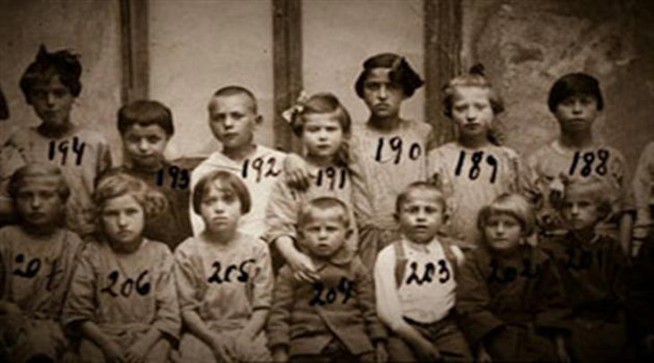“Ochberg’s Orphans”, Jewish children orphaned by the pogroms in Eastern Europe, who were brought to South Africa to start new lives.

Ochberg and Bobrow spent three months travelling through the region, gathering together hundreds of Jewish orphans. Towards the end of this period, Ochberg wrote in a letter: “I have been through almost every village in the Polish Ukraine and Galicia and am now well acquainted with the places where there is at present extreme suffering. I have succeeded in collecting the necessary number of children, and I can safely say that the generosity displayed by South African Jewry in making this mission possible means nothing less than saving their lives. They would surely have died of starvation, disease, or been lost to our nation for other reasons.”
Officially, Isaac Ochberg rescued 197 Jewish orphans. (Some accounts put that number lower, at 171.) Yael Pritzker, whose grandmother and great aunts were saved, notes that in reality he saved even more. Her Great Aunt Clara was about sixteen when she arrived in South Africa – too old to count towards Jan Smuts’ definition of orphans that Ochberg was allowed to save – so Isaac Ochberg called her a nurse’s assistant and brought her as a staff member accompanying her sisters.

Some Were Not Truly Orphans
Some of the “orphans” Ochberg rescued weren’t truly orphans according to Smuts’ definition, either, Yael notes. “Some weren’t orphans: their parents couldn’t support their kids any more. Facing starvation and horrific violence, some desperate parents sent kids into the forest to escape pogroms.” Many of the orphans Ochberg rescued were terrified Jewish children he found starving and traumatized, wandering in the forests of Eastern Europe.
One orphan, Fanny Frier, later recalled the that she and the other children were told that Ochberg was going to rescue them. “He was going to take some of us away with him and give us a new home on the other side of the world…. (W)hen he appeared with his reddish hair and cheery smile, we all took a great liking to him and called him ‘Daddy’. He would spend hours talking to us, making jokes and cheering us up.”
The ship carrying the “Ochberg Orphans” travelled to London and then on to Cape Town. Fanny Frier stated, “Never to my dying day shall I ever forget our first sight of the lights of Cape Town and then the tremendous reception when we came ashore with half the city apparently waiting on the quay for us.”

Not Enough Homes to Adopt the Orphans
Sadly, the group of orphans was so large that the Jewish orphanage in Cape Town ran out of room and some orphans were sent to a Jewish orphanage in far-away Johannesburg. Some of the orphans were adopted by South African Jewish families, but many grew up in the orphanages. When it came to the Gaby sisters, Yael Pritzker recalls, they all “married out of the orphanage,” moving directly from their orphanages into their new homes with their husbands.
At the same time he was rescuing European Jews, Isaac Ochberg was also working to build the nascent Jewish state. His 1937 gift to the Jewish National Fund is the largest donation that organization has ever received, even now 84 years later, and was used to purchase land for Kibbutz Dalia and Kibbutz Gal’ed in Israel’s north. Much of the region used to be informally known as Even Yitzchak, or Stone of Isaac, after Isaac Ochberg.
Isaac Ochberg passed away in 1938, but his legacy continues.
Yael Pritzker recalls that when her father grew up in South Africa, he was always keenly aware who had been rescued from certain death in 1921. Not only did his mother Peggy owe her life to Ochberg’s life-saving mission, so did their downstairs neighbor and many other Jews in the area. “His parents would always comment ‘Oh he’s an Ochberg Orphan,’ and ‘she’s an Ochberg Orphan’,” Yael remembers.

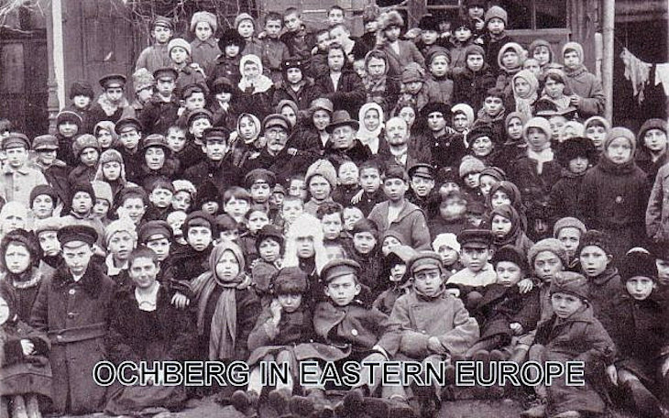Isaac Ochberg (center) with his rescued orphans in 1921 in Eastern Europe before leaving for South Africa.

Many of these survivors were traumatized. Some struggled with depression. Some refused to ever wear the color red, Yael recalls hearing, since the color was associated in their minds with the blood of their parents and other relatives they saw flowing during pogroms. Her own grandmother rarely spoke of her earlier life in Kovno, but she was always incredibly grateful to “Father Ochberg” who’d given her – as well as her sisters and hundreds of other Jewish children – a second chance to live. Thousands of Jews around the world today are alive because of the Jewish children Isaac Ochberg saved.
“What Ochberg did was unbelievable,” Yael notes. “He took it on himself. He could have left it to other people, but he went himself to these shtetls and orphanages.”
This month, on the hundredth anniversary of Isaac Ochberg’s life-saving journey, Isaac Ochberg’s legacy is being honored in the hundreds of Jewish homes that exist today because of his actions.

Reprinted from the Parshat Tzav website of Aish.com

